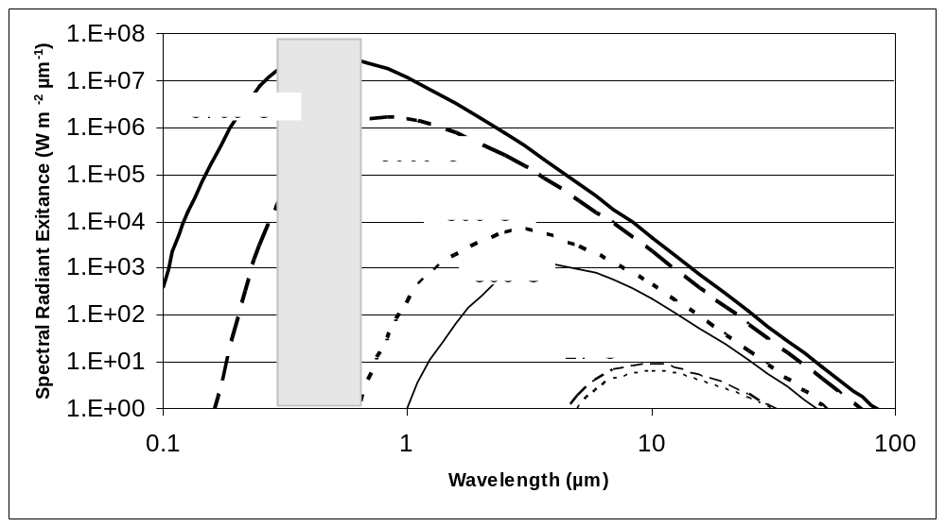
Figure 1. Spectral Radiant Exitance as calculated with Planck’s equation for a black body (emissivity =1.0) at a range of temperatures.

Table 1. Temperature and wavelength of maximum emittance for several objects.
 | celsius | Kelvin | nm | µm | m
Iron bar | 1.0E+03 |  | 2.3E+03 | 2.3 | 2.3E-06
Soil | 33.0 |  | 9.47E+03 | 9.47 | 9.47E-06
Lamp |  | 2945.0 | 984.04 | 0.98404 | 9.8404E-07
Star |  | 556 | 521 | 5.21 | 5.21E-06

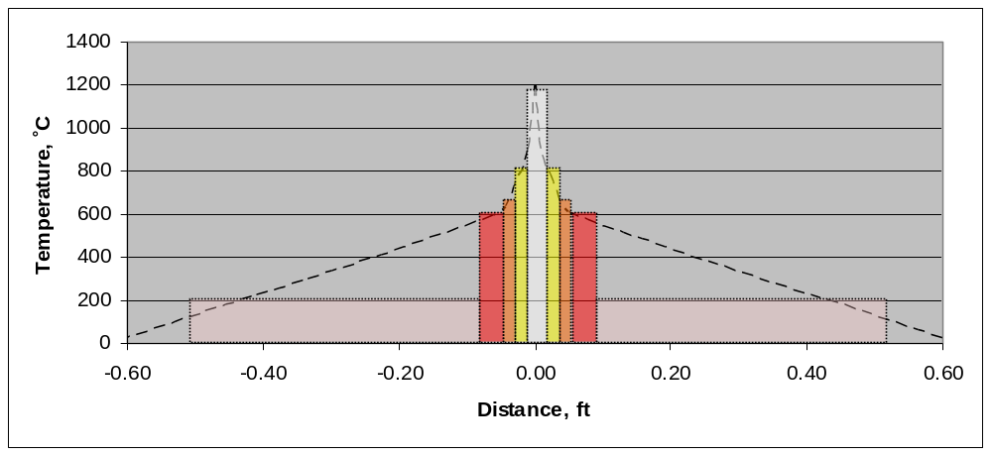
Figure 2. Temperature profile across a candle flame from A to A’.
Figure 2 illustrates the temperature profile across a candle flame. It also shows the portion of the electromagnetic spectrum emitted by the burning candle as the distance from the burning candle wick increases. At the center of the flame, the temperature is the highest and energy is emitted at the ultraviolet and blue wavelengths. The temperatures decrease further from the center of the flame and energy is emitted at longer wavelengths making the yellow, orange and red spectrums visible. After the flame is no longer visible, it is still possible to detect infrared energy for some distance from the flame. The center portion of the flame appears to be white because the eye is looking through all portions of the flame including the cooler red, orange and yellow wavelengths. As a result, the eye picks detects light across the entire electromagnetic spectrum thus the center of a candle flame is detected as being white.

